
Symbiosis Institute of Technology, Pune
Faculty of Engineering
CSE- Academic Year 2026-27
Java Programming – Lab Batch 2024-28
Lab Assignment No:- 20
Name of Student | Aarushi Raizada
PRN No. | 25070122002
Batch | 2025-29
Class | A1
Academic Year & Semester | 2026 SEM III
Date of Submission | 28th August 2026
Title of Assignment: | Develop a Java application to establish connectivity with a database and perform INSERT, UPDATE, and DELETE operations.
Theory  Practice questions | JDBC allows Java applications to perform database manipulation using SQL Data Manipulation Language (DML) statements such as INSERT, UPDATE, and DELETE. The INSERT statement adds new records into database tables, UPDATE modifies existing records, and DELETE removes unwanted records. These operations are executed using the Statement or PreparedStatement interface. PreparedStatement is generally preferred because it supports parameterized queries, improves performance, and prevents SQL injection attacks. Proper transaction management ensures that database modifications are performed safely and consistently. These operations form the basis of almost every database-driven application such as banking systems, hospital management systems, and student information systems  1. Create a Java application to manage employee records using CRUD operations  import java.sql.*;  public class Main {  public static void main(String[] args) {  String url = "jdbc:mysql://localhost:3306/studentdb";  String user = "root";  String password = "root";  try {  Class.forName("com.mysql.cj.jdbc.Driver");  Connection con = DriverManager.getConnection(url, user, password);  Statement stmt = con.createStatement();  // INSERT  stmt.executeUpdate(  "INSERT INTO employee VALUES (101, 'Rahul', 40000)"  );  System.out.println("Employee inserted");  // UPDATE  stmt.executeUpdate(  "UPDATE employee SET salary = 45000 WHERE id = 101"  );  System.out.println("Employee updated");  // DELETE  stmt.executeUpdate(  "DELETE FROM employee WHERE id = 101"  );  System.out.println("Employee deleted");  con.close();  } catch (Exception e) {  System.out.println(e);  }  }  }  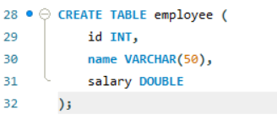  2. Create a Java application to manage student records using CRUD operations. Perform Create, Read, Update, and Delete operations on student details such as roll number, name, course, and marks using a database.  import java.sql.*;  public class Main {  public static void main(String[] args) {  String url = "jdbc:mysql://localhost:3306/studentdb";  String user = "root";  String password = "root";  try {  Class.forName("com.mysql.cj.jdbc.Driver");  Connection con = DriverManager.getConnection(url, user, password);  Statement stmt = con.createStatement();  // INSERT  stmt.executeUpdate(  "INSERT INTO student VALUES (4, 'Neha', 'CSE', 92)"  );  System.out.println("Student inserted");  // UPDATE  stmt.executeUpdate(  "UPDATE student SET marks = 95 WHERE rollno = 4"  );  System.out.println("Student updated");  // DELETE  stmt.executeUpdate(  "DELETE FROM student WHERE rollno = 4"  );  System.out.println("Student deleted");  con.close();  } catch (Exception e) {  System.out.println(e);  }  }  }  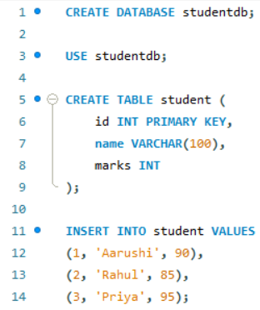
Output Screenshots (if applicable) | Ans 1  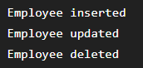  Ans 2  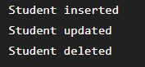
Conclusion | In this experiment, we learnt to perform database modification operations using JDBC.

